The Story of the Nativity: The Truth of Christmas
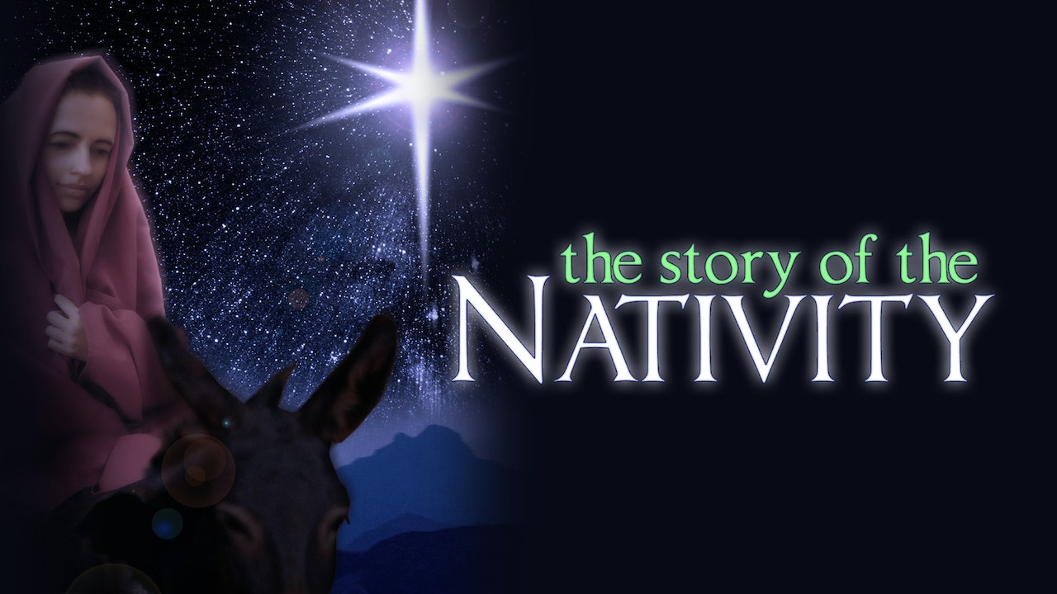
The story of the birth of Jesus is often misunderstood. But this fast-paced, thought-provoking look at the true story of the Nativity clears away widespread misunderstandings of Jesus' origin. Join top scholars, inspirational speakers, and popular authors as they explain the story behind the story of the birth of Jesus.
Explore the true story of Mary and Joseph, Jesus's miraculous conception, the birth of John the Baptist, the journey of Mary and Joseph to Bethlehem, the Star of Bethlehem, and the birth of Jesus. This is an invaluable tool for believer and unbeliever alike to learn more about Jesus of Nazareth and about the truth of Christmas.
Join us for this Advent Lesson Monday, December 12th Starting at 7:00p.m. in Resurrection Hall.

